AI Assignment Report - Genetic Algorithm

* Pranav Shailesh Ruparel (2020A7PS0973G)

1. The algorithm was run on edge sizes – 100,200,300,400,500 on 10 different randomly built graphs, with initial population of 50 members across 50 generations. The mutation rate was set to an arbitrary 1 mutation in 10 samples.
2. Here is the result of the best output in each case:
3. Number of Edges: 100

Best State:

1:G, 2:R, 3:G, 4:G, 5:G, 6:G, 7:B, 8:B, 9:B, 10:B, 11:B, 12:B, 13:B, 14:G, 15:R, 16:B, 17:R, 18:B, 19:R, 20:R, 21:R, 22:G, 23:R, 24:G, 25:R, 26:G, 27:R, 28:R, 29:R, 30:B, 31:G, 32:R, 33:R, 34:G, 35:R, 36:G, 37:G, 38:B, 39:B, 40:B, 41:B, 42:B, 43:G, 44:B, 45:G, 46:B, 47:B, 48:G, 49:G, 50:R

Fitness Value of Best State: 50

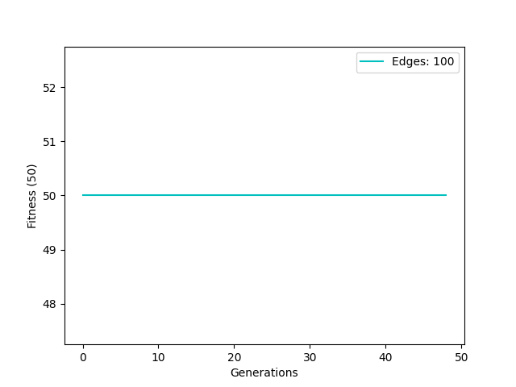

1. Number of Edges: 200

Best State:

1:B, 2:B, 3:R, 4:R, 5:G, 6:B, 7:G, 8:R, 9:B, 10:R, 11:R, 12:B, 13:B, 14:G, 15:R, 16:R, 17:R, 18:R, 19:R, 20:B, 21:R, 22:G, 23:R, 24:R, 25:G, 26:G, 27:G, 28:R, 29:R, 30:B, 31:G, 32:R, 33:R, 34:B, 35:G, 36:G, 37:R, 38:B, 39:B, 40:B, 41:B, 42:G, 43:R, 44:G, 45:G, 46:G, 47:B, 48:G, 49:R, 50:R

Fitness Value of Best State: 50

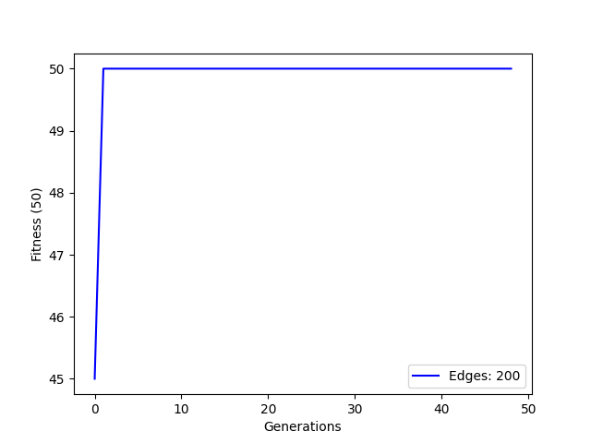

1. Number of Edges: 300

Best State:

1:B, 2:B, 3:R, 4:R, 5:B, 6:B, 7:B, 8:B, 9:B, 10:R, 11:R, 12:B, 13:B, 14:R, 15:G, 16:G, 17:B, 18:R, 19:G, 20:R, 21:R, 22:G, 23:R, 24:G, 25:B, 26:B, 27:G, 28:G, 29:G, 30:B, 31:G, 32:B, 33:R, 34:G, 35:G, 36:B, 37:R, 38:R, 39:G, 40:G, 41:G, 42:G, 43:R, 44:R, 45:R, 46:R, 47:G, 48:G, 49:B, 50:B

Fitness Value of Best State: 50

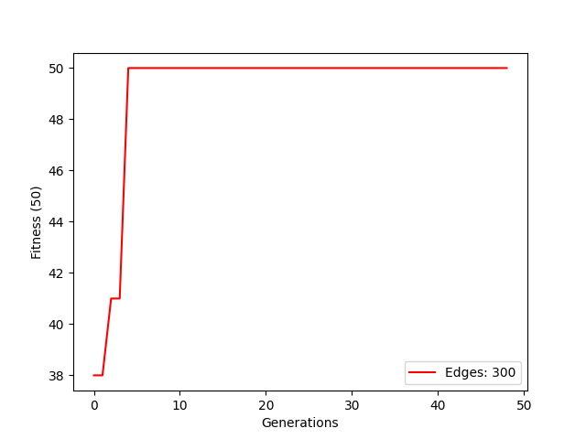

1. Number of Edges: 400

Best State:

1:R, 2:R, 3:G, 4:G, 5:B, 6:G, 7:R, 8:B, 9:G, 10:G, 11:B, 12:R, 13:B, 14:B, 15:R, 16:G, 17:R, 18:G, 19:B, 20:B, 21:B, 22:G, 23:G, 24:G, 25:R, 26:G, 27:G, 28:G, 29:G, 30:B, 31:B, 32:B, 33:G, 34:B, 35:R, 36:G, 37:B, 38:G, 39:G, 40:B, 41:R, 42:G, 43:B, 44:G, 45:G, 46:B, 47:G, 48:R, 49:R, 50:G

Fitness Value of Best State: 50

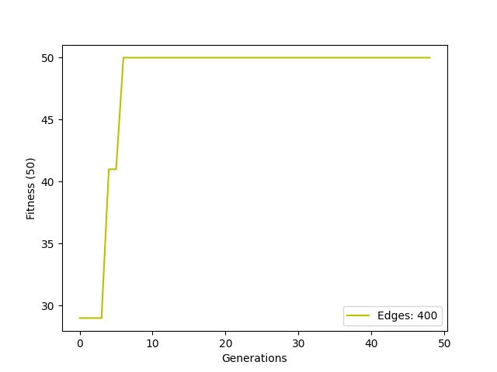

1. Number of Edges: 500

Best State:

1:G, 2:G, 3:B, 4:R, 5:R, 6:B, 7:B, 8:B, 9:G, 10:B, 11:B, 12:G, 13:B, 14:R, 15:B, 16:B, 17:B, 18:R, 19:R, 20:B, 21:B, 22:R, 23:R, 24:R, 25:B, 26:B, 27:R, 28:R, 29:R, 30:B, 31:B, 32:B, 33:G, 34:B, 35:B, 36:B, 37:R, 38:R, 39:R, 40:B, 41:B, 42:B, 43:R, 44:R, 45:B, 46:G, 47:R, 48:G, 49:B, 50:R

Fitness Value of Best State: 50

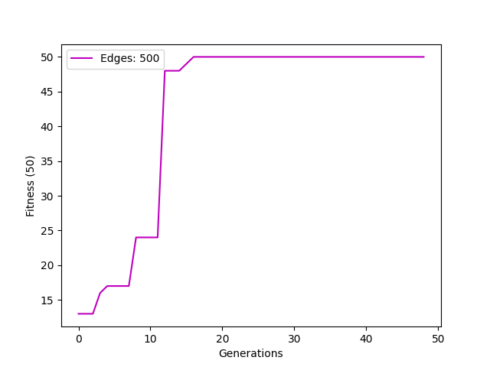

1. Here is the plot of how the maximum fitness function changes over generations in the best case, for different edges sizes.

